Display prime numbers between 1 and 100 or 1 and n

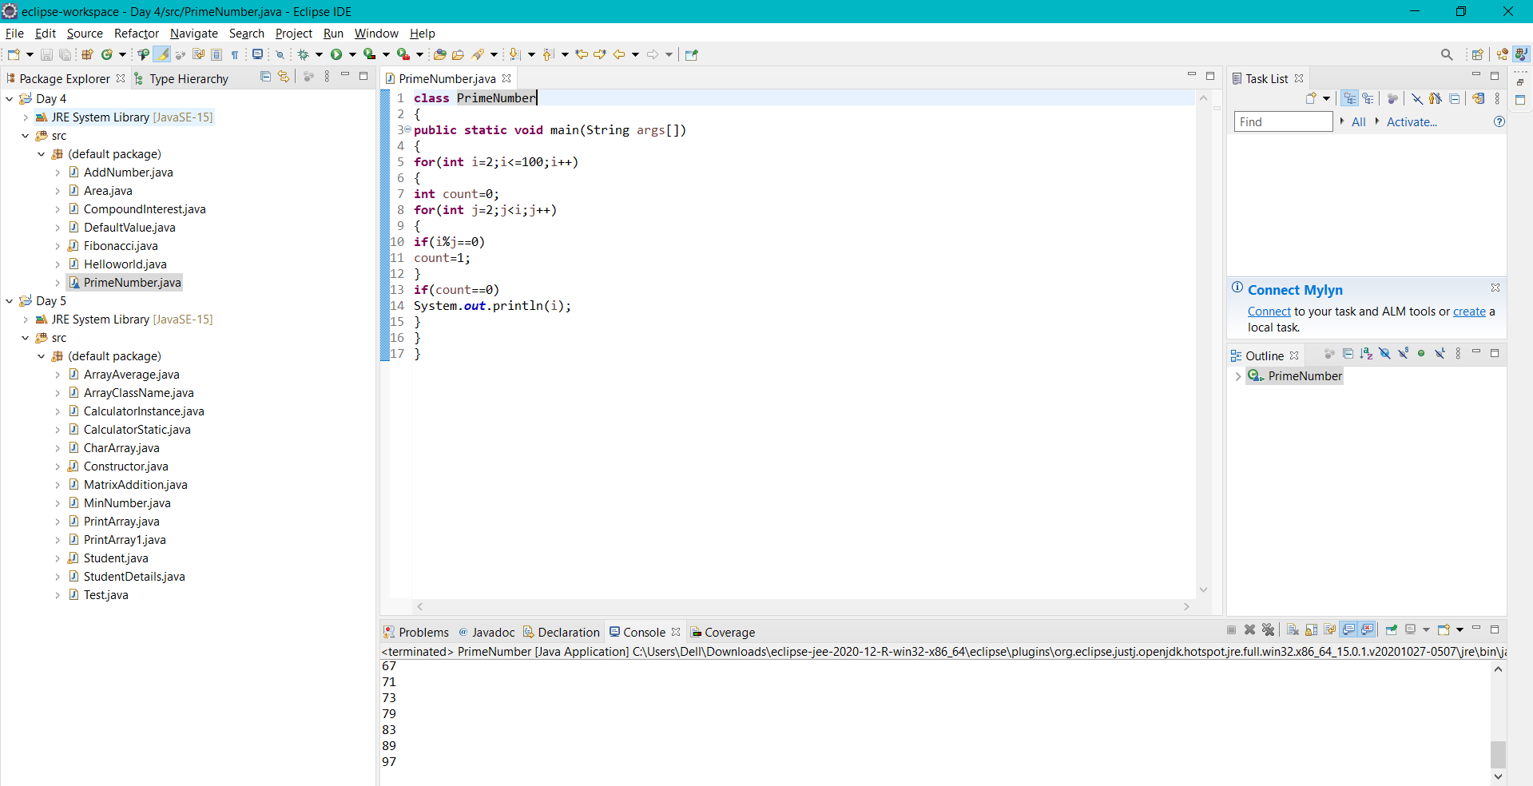

Check if a number is palindrome or not

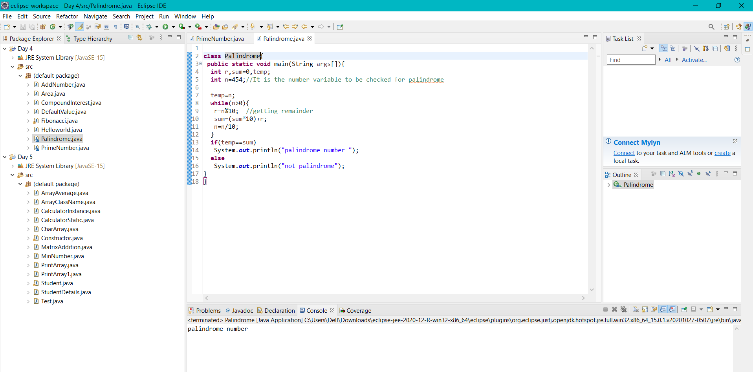

Find the square root of a number without sqrt method

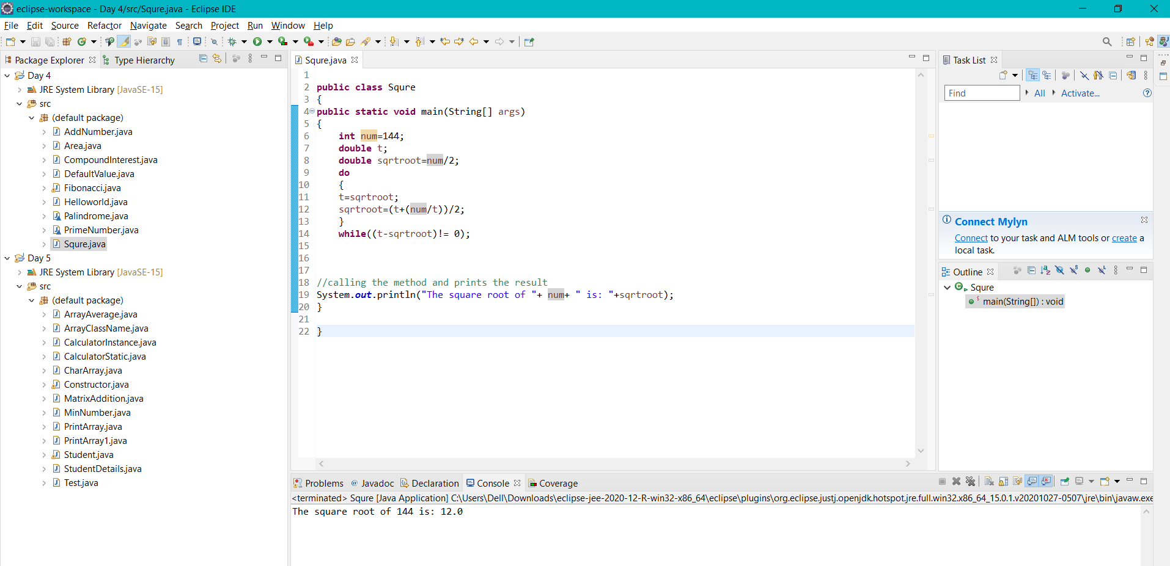

Calculate grades of students using their marks

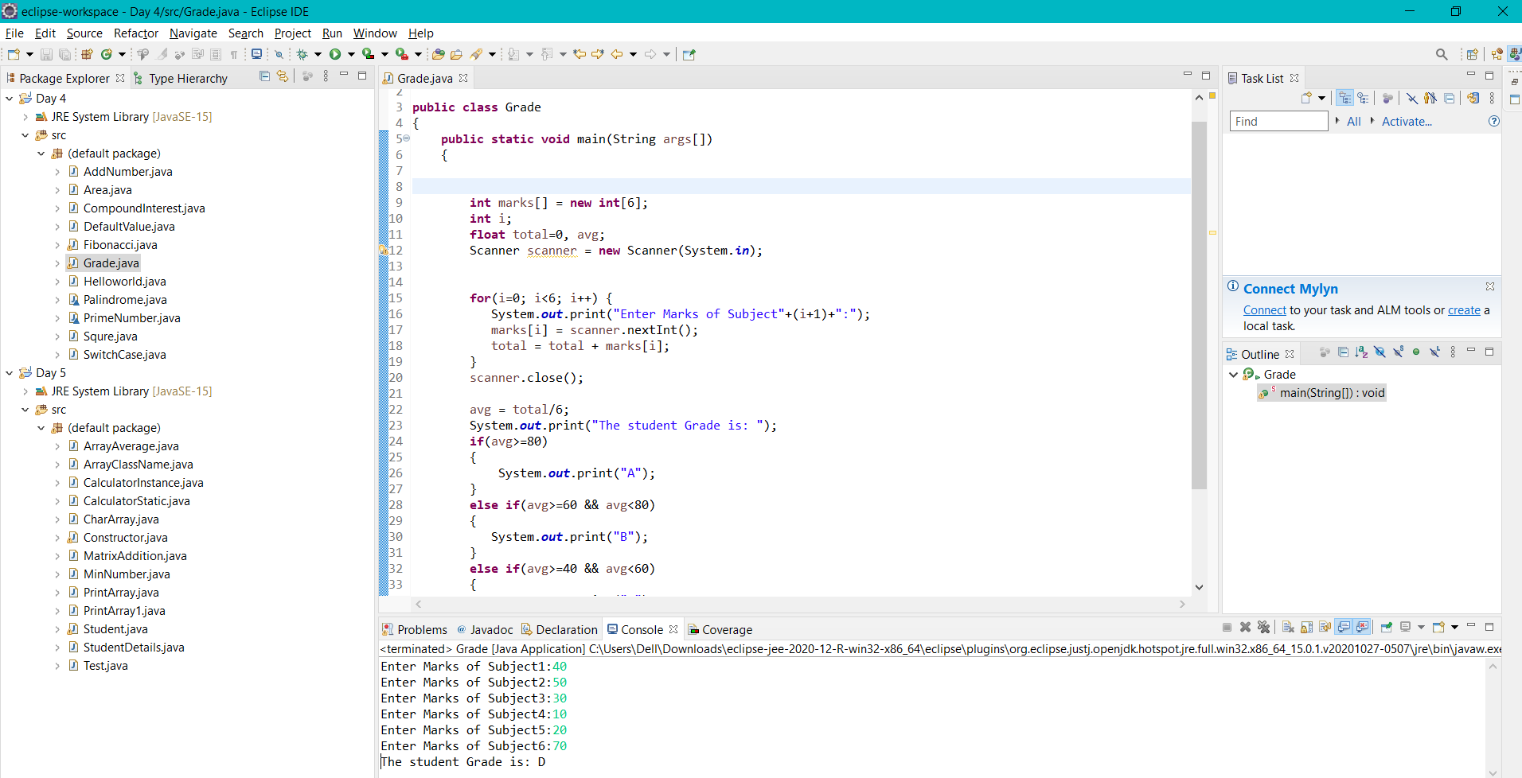

Use switch case, check 0 to 9 numbers.

